MSXPi Interface Version 1.0
Ronivon Costa
ronivon.costa@gmail.com

Technical Reference Manual

Table of Contents
1MSXPi Overview 4
1.1What's new in version 1.0 5
2Users Guide 7
2.1MSXPi ROM 7
2.2 MSXPIEXT.BIN 8
2.3 MSXPi CALL Commands 8
2.4Examples using CALL Commands 9
3MSXPi Architecture and Behavioural Description 11
3.1Sequence Diagram for Commands 12
4Connecting MSXPi to the Raspberry Pi 14
5MSXPi Programmer's Reference 16
5.1MSXPi I/O (MSXPI_IO.ASM) 16
5.2MSXPi BIOS (MSXPI_BIOS.ASM) 17
5.3BIOS Functions Address Table in ROM 20
5.4MSXPi server in C 21
5.5MSXPi Server in Python 22
6SPI Implementation in the MSXPi Interface 23
7Appendix 25
7.1Development Tutorial 25
7.2Previous Versions 25
MSXPi Client Commands 25
For ROM-less MSXPi 26
7.3Appendix 2: Pi - GPIO Pin Numbering 27

MSXPi Interface v1.0 is a design crearted and implemented by Ronivon Costa, 2016 – 2020.

MSXPi Overview
MSXPi is a solution to allow MSX computers user Raspberry Pi devices as generic peripherals. I say it is a solution because it is a set of software and hardware components put together to allow such functionality.
MSXPi hardware is composed of a MSX compatible interface to connect to the slot cartridge of any MSX 1,2,2+ and Turbo R. Due to some specific hardware implementation of some MSX models, the interface may not work on all MSX models. Also, the integrated MSX-DOS only works on 64K machines.
MSXPi software is composed of different components running on MSX and on Raspberry Pi. On the Raspberry Pi side, there is the msxpi-server component which listen for GPIO events, decode serial data using a few pins and transform that data into control commands and parameters. On the MSX side, there are different software components depending on how the user wants to use MSXPi.
- MSX-DOS is stored in the MSXPi EPROM. This is the MSX-DOS v1.0 customized with the MSXPi low level drivers to allow boot from MSX standard disk images stored on Raspberry Pi. The EPROM also contain a set of CALL commands to use from BASIC.
- MSX-DOS commands - these are “.com” commands that implement a series of functionalities on MSX-DOS allowing greater experience with MSXPi. This is the current approach to develop software for MSXPi, since it covers most of the users abse and allows for greater flexibility.
- MSXPIEXT.BIN with CALL commands to extend BASIC to access MSXPi without the need of the EPROM. This program adds a set of CALL commands in the RAM area in $4000, allowing new commands to be installed from DISK runnning “msxpiext.bin”. It actually installs the MSXPi BIOS into a simulated ROM cartridge installed in RAM.

In the next sections we will discuss the resources currently available for MSXPi, and how to use them.

What's new in version 1.0
This version is a major overhaul of the MSXPi. It was added support to the Z80 /wait signal, allowing a change to the low level drivers to be simpler, more straighforward and easy to support and add software. To support this major change, existing interfaces will need a small simple hardware mod, and to use the new software versions available.
Changes on Version 1.0
- Requires a Mod to the interface: remove the BUSDIR jumper. Wire the CPLD pin 11 to the MSX /wait signal (requires a simple soldering skills).
- CPLD logic redesigned to implement the /wait signal. Uses less logic, less cycles to implement the serial/paralell conversion.
- The full duplex logic was removed from the CPLD logic, which means that a write will never return any valid data. A write/read sequence needs to be implemented in the client software as two separate operations.
- All client applications re-engineered to support the new interface architecture.
- The server-side application also re-engineered to be less complex, support the new serial/paralell logic - there are now two separate methods: send_byte() and receive_byte().
- MSX-DOS ROM was reompiled to support the new intrface architcture.
- Should have a performance improvement since the /wait implementation will now suspend MSX processing only during the exact time necessary for the Raspberry Pi to process the requests.

Changes from Version 0.8.2
- A more complete set of CALL commands
Starting at ROM build 20171230.00077, MSXPi contain a new set of CALL commands in ROM allowing it to be used in BASIC and from within BASIC programs.
Not all MSXPi commands are be compatible, but some are (such as PRUN,PSET,PDIR) and allow exhange of data with Pi in BASIC.
- The new CALL commands also available as a BASIC extension (msxpiext.bin) for MSXPi that interfaces with older ROMs.
- New server in Python
The msxpi-server has been ported to Python. This improves development time, at the same time allowing same level of transfer rate since the transfer of blocks of data are still using the C function.
- IRC client and WhatsUp client
Two messaging clients are available, in BASIC, for these messaging platforms. They use the new CALL comands, and are compatible with either the new ROM or the msxpietx.bin extension.

Users Guide
This release comes with an EPROM containing MSX-DOS 1.04. This is a custom DOS, modified from MSX-DOS 1.03 and containing a disk driver to access sectors of standard MSX disks stored on Rapsberry Pi disk images on SD card.

The EPROM software must match the Raspberry Pi server component, or some commands will fail. A newer version of the server component can be used, but not an older version.

MSXPi boots into MSX-DOS on MSXPi drive A: which is mapped to the disk image in /home/pi/msxpi/disks/msxpiboot.dsk. The MSX can also boot from MSX-DOS2 on another interface, and still have access to MSXPi files on the Raspberry Pi.
Drive B: is mapped to /home/pi/msxpi/disks/msxpitools.dsk which contains all currently available DOS commands to use with MSXPi and some other tools.

Both disk images are provided in the MSXPi distribution.

Note1: The MSX-DOS in the MSXPi ROM can be skipped pressing “P” at the same time the MSX is switched on. This allow skipping the MSXPi MSX-DOS and boot into another DOS cartridge such as ATA-IDE or MFR.

Note 2: When another MSX-DOS2/Nextor compatible interface is connected to MSX, MSXPi can boot from a DOS2 disk image stored on RPi.

MSXPi specific commands starts with “P”, such as “PDIR”, “PDATE”, “PCOPY” and so on. There are a few exceptions though, such as the command “PRUN” to run commands directly on Rapsberry Pi.

From MSX-DOS command line, you can use all resources available to MSX-DOS1, such as game loaders and other programs.

When booting from MSXPi, you can also have a second disk drive interface attached (such as ATA-IDE or MegaFlashRom SD). These drives will be accessible from MSX-DOS1 and you can exchange files between MSXPi disk images and those drives. See also Note 2 above.

The MSXPi tools and usage will be covered in a later section.

MSXPi ROM
The EPROM contain the MSX-DOS, allowing MSX to boot into MSX-DOS directly from the interface. It constains also a set of CALL commands available to the user from BASIC prompt:

- CALL MSXPIVER
Display the ROM version and available commands

- CALL MSXPISTATUS
Test connection with Raspberry Pi and display status

- CALL MSXPILOAD
Load the MSXPi Client from Raspberry Pi, and execute. The next section provide information on how to use this client (deprecated).
- CALL MSXPI
Run MSXPi commands on RPi. Can optionally use a buffer to store data returned by the command.
- CALL MSXPISEND
Send any data to RPi, which can be a command, data, or both.
- CALL MSXPIRECV
Receive data from Pi.

MSXPIEXT.BIN
MSXPIEXT.BIN is an extension for BASIC, that can be used by older MSXPi which ROM was not updated to latest releases. This command should be loaded and executed to add new CALL commands to MSX-BASIC, and will only work on 64KB computers because it install itself as a ROM cartridge in RAM area starting at address #4000.
To install the extension, run the following command from BASIC:
bload”msxpiext.bin”,r
A short help is diplayed with the available commands.

MSXPi CALL Commands
These commands use a buffer to exchange data with RPi. This buffer has the following format in memory:
Address | Buf+0 | Buf+1 | Buf+2 | Buf+3 up to Buf+3+Size
Content | Return code | Size (lsb) | Size (msb) | Data (this area size=lsb+256*msb)

The followind commands are available after installing the extension:
CALL MSXPI(”<output>,<buffer>, command”>)
This command does not currently use the return code and size areas, and the data starts at the address passed.
“output” and “buffer” are optional parameters.
output:
0 : do not print output
1: print output to screen (this is the default)
2: store output in buffer

buffer:
4 digit hex memory address. For example, “C000”

command:
Any supported command, such as “pdir”, “pcd”, “prun”,”pset”, etc.

CALL MSXPISEND(“buffer”)
Send contents of buffer to RPi (it uses the SENDDATABLOCK function from msxpi_bios.asm). This command uses the buffer format as specified above. The First byte should be left unused, and the next two bytes should contain the size of the data to transfer.
CALL MSXPIRECV(“buffer”)
Read data from RPi and store in the buffer (it uses the RECVDATABLOCK function from msxpi_bios.asm). After completing the transfer, the first byte will contain the return code and the next two bytes will contain the number of bytes received.

Examples using CALL Commands
2.3.1 CALL MSXPI
call msxpi(“pdir”)
call msxpi(“0,pdir”)
call msxpi(“1,pdir”)
call msxpi(“2,D000,pdir”)
Note: in the last example, since we passed flag “2”, the output of the command is saved in the buffer starting at address D000H.

2.3.2 CALL MSXPISEND
In this example, we will send data (a simple “TST” command) to RPi and verify the return code received.
10 gosub 100 ' Send a command to RPi
20 rc=peek(&hD000): ? hex$(rc) ' Get Return Code
50 end
99 ' Send data to RPi – a text command in this case
100 POKE &HD000,0 ' This is the area reserved for the return code
110 POKE &HD001,3:POKE &HD002,0 ' This is the buffer size (LSB,MSB)
120 POKE &HD003,ASC('T')
130 POKE &HD004,ASC('S')
140 POKE &HD005,ASC('T')
150 CALL MSXPISEND(“D000”) ' Send command TST to RPi
160 RETURN

2.3.3 CALL MSXPIRECV
This example receive data from RPi and print on screen. For this reason, it is convenient that the data is ascii in a valid range so it will be correcly displayed on screen. This same routine also works with any binary data, in which case it should be stored in the buffer instead of presentd to screen.
10 gosub 100 ' Receive data from RPi
20 rc=peek(&hD000): ? hex$(rc) ' Get Return Code
30 if rc=&hE0 then gosub 200 ' If RC=RC_SUCCESS then print data
50 end
99 ' Receive soma data from RPi
100 POKE &HD000,0 ' This is the area reserved for the return code
110 POKE &HD001,0:POKE &HD002,0 ' This is the area reserved for buffer size
120 CALL MSXPIRECV(“D000”) ' Received data from RPi
130 RETURN
200 S=PEEK(&HD001)+256*PEEK(&HD002) ' Get size of buffer
210 FOR M = 0 TO S-1 ' Will read all bytes iin the buffer...
220 PRINT CHR$(PEEK(&HD003)+M); ' and print on screen.
230 NEXT M:RETURN

MSXPi Architecture and Behavioural Description
Following picture illustrate the high level design of the MSXPi interface.
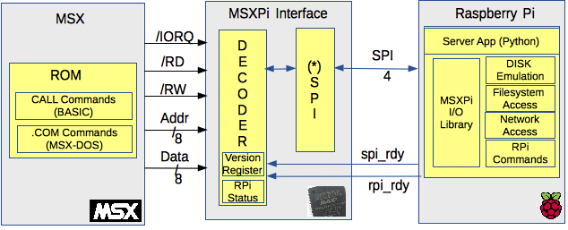

Figure 1: Architecture

1. MSX starts a transfer writing or reading I/O port 0x5a
2. MSXPi decode the address and signals, and decide if should enable MSXPi
3. MSXPi send /cs signal (low) to RPi, and /wait (low) to MSX
4. RPi Starts pulsing the SPI clock signal (this will trigger the MSXPi serial/paralell process)
6. MSXPi serial/paralell process will write or read the SPI signals, depending on the operation:
5.a For MSX OUT operation, MSXPi will serialize the MSX data and write to mosi pin
5.b For MSX IN operation, MSXPi will convert the bits from mosi pin to paralell and store in a latch
6. RPi will pusle signal spi_rdy to flag that the transfer is completed.
7. MSXPi will set the MSX data bus with the value received from Rpi (if a MSX IN operation)
8. MSXPi will release both RPi and MSX by:
8.a Setting /cs to HIGH
8.b Setting /wait to Tri-State ('Z')
The interface uses serial transfer between CPLD and Raspberry Pi. Because of this technical feature, it is not ideal for some applications that require high throughput, such as graphics applications specially because the server component is implemented in a slow, interpreted language (Python). Currently the benchmark transfer rate is approximately 5KB per second (Kilo Bytes / s).

The interface between MSX and RPi is made using a CPLD tolerant to 5 volts, the EPM3064 from Altera. In this CPLD it is implemented the logic to decode the I/O port and other MSX bus signals (/wr, /rd, /iorq) and transfer a byte between MSX and Raspberry Pi using a simple shift register clocked by the Raspberry Pi once the MSX writes or read to the MSXPi port. Due to the fact that the clock for the transfer is generated by the RPi, the speed is mandated by that device, which will be impacted by background applications running along with the msxpi-server.py component.

The client application s (.com commands) was developed in the Assembly Z80 language, and the server application Python. Performance can be improved by developing components in C language at the server-side, if needed.

On the Raspberry side, the application runs on the Raspbian, and is automatically initialized every time the Pi is connected by the systemd service.
By using a standard linux system, the solution allows a wide range of applications to be easily developed through the use of existing tools in Raspberry, both for programming and for accessing Pi GPIOs.

Sequence Diagram for Commands

Figure 1 show he sequence diagram for a command that takes the Raspberry Pi a long time to complete. Such commands must be flagged to the MSX, to allow it to wait inside a loop until the command is processed and the data ready to be read.
These commands cannot be put on hold using the Z80 /wait signal, because if the command takes longer that a few seconds to complete, the Z80 stops refreshing the RAM memory and data are lost, resulting in a crash of the computer.
Long lived commands will return a “RC_WAIT” return code to MSX. Upon receiving this return code, the program must poll port 0x5b until it returns zero, indicating that the Rpi has completed the processing and is is ready to send the data back. At this point, the MSX program can start reading port 0x5a for data.

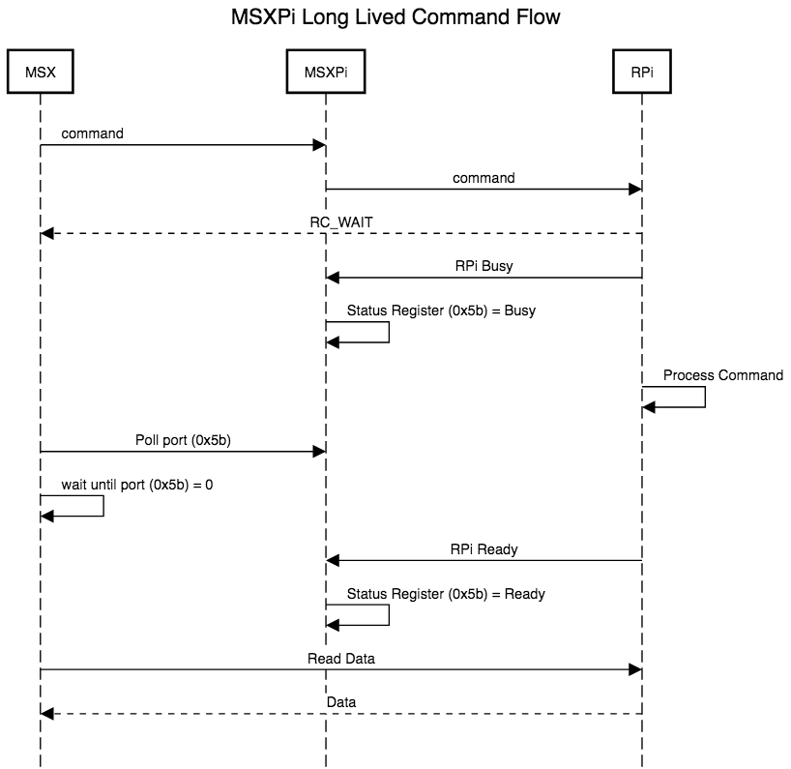

Figure 2: Sequence Diagram for Long Lived Command

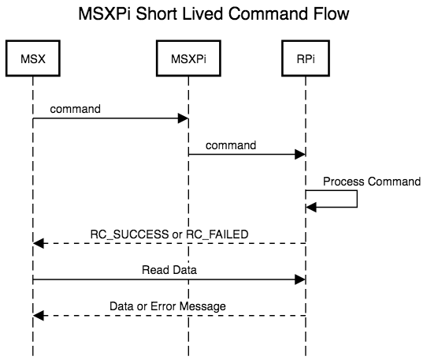

Figure 3: Sequence Diagram for Short Lived Command

Connecting MSXPi to the Raspberry Pi
The interface is compatible with any model of Raspberry Pi, although it was developed for the "Zero" model, so that it is fully incorporated into the cartridge. The only exposed parts will be SD, USB and LED card slots.
The GPIO pins (see Appendix 1) of the Pi used by the interface are:

GPIO | Purpose | Direction | Enabled | CPLD Pin
21 | /CS (SPI Chip Select) | Input | 0 | 28
20 | SCLK (SPI Clock) | Output | N/A | 34
16 | MOSI (Interface out) | Input | N/A | 5
12 | MISO (Interface in) | Output | N/A | 41
25 | PI_Ready | Output | 1 | 12
 | GND (Pin 4) | N/A | N/A
 | VCC (Pin 6) | N/A | N/A

When using RPi Zero, power is supplied by MSX.
When using RPi 1,2 or 3, RPi must be connected to an external power supply.
To attach Raspberry Pi Zero to the interface, use the photo in illustration 2 as a reference. As for software version 1.0, only 7 PINs are used on Raspberry Pi Zero as indicated with the red arrows. Soldering is only required in the signaled pins.
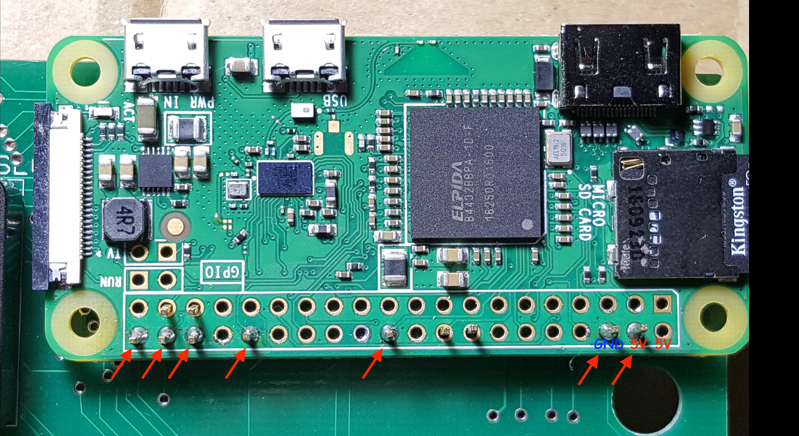
Figure 2: Attaching Raspberry Pi Zero to the interface

To attach a Raspberry Pi model B +, 2 and 3 to the interface, use the picture in illustration 3 as a reference.

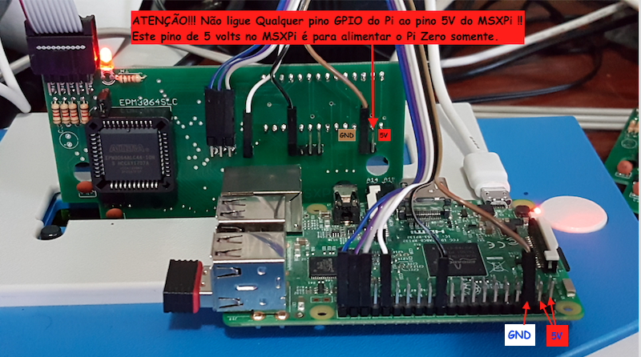
Figure 3: Connection of the B +, 2 and 3 models

Note: It is essential that the MSXPi GND (brown wire) is connected to the Raspberry Pi. Without this connection, the signals on the interface pins will not be transmitted correctly.

MSXPi Programmer's Reference
This section describes the MSXPi specific IO library. This library is hardware-dependent and should be always be used instead of trying to access the hardware directly. This will allow for greater compatibility with future releases of the hardware.
The MSXPi software library consist of a set of Z80 assembly routines on the MSX side, and a C and Python framework on the Raspberry Pi side. In this section we focus on the MSX-side library.
The MSXPi project has the following structure:
/asm-common/include/include.asm → contain constant definitions and MSX BIOS labels
/asm-common/include/basic_stdio.asm → contain the PUTCHAR call for programs in BASIC environment and cartridge programs (such as MSX-DOS driver)
/asm-common/include/msxdos_stdio.asm → contain the PUTCHAR call for MSX-DOS programs, and also a MSX-DOS wrapper for the SENDPICMD bios routine.
/asm-common/include/msxpi_bios.asm → Contain all data transfer and other bios functions (hardware-independent) used by MSXPi programs.
/asm-common/include/msxpi_io.asm → This file contain the hardware-dependent I/O functions for MSXPi. All functions in this library access MSXPi hardware ports, and are called by functions in the libraries mentioned previously.
/asm-common/include/msxpi_api.asm → contain extra-routines that might be useful.
Next section will describe the bios functions only.

MSXPi I/O (MSXPI_IO.ASM)

CHKSPIRDY

Label : CHKPIRDY
Purpose : Read the MSXPi Interface status register (port 0x56)to determine the
status of the Interface and Pi Server App. This function should
return zero when Pi is responding, and 1 when not listening for commands.
Input : None
Output : Flag C: Set when Pi not responding.
Registers : AF is modified
Usage notes: Pi is determined as responding when I/O control port 56h returns zero. This routine loop 65535 times before it will return with error (zero not detected on that port).
PIEXCHANGEBYTE
Label : PIEXCHANGEBYTE
Purpose : Send a byte to Pi (write to data port 5AH) and read a byte back. Usually,
the byte read at this cycle is meaningless because Pi send whatever is available
on its internal register during any transfer. If you send a byte expecting to
receive a valid response, than you must call this function a second time (this is
because Pi needs time to process your byte and execute whatever command it
need to produce the expected answer).
Input : Register A: byte to send.
Output : Flag C: Set if there was an error
Register A: byte received
Registers : AF is modified
PIREADBYTE
Label : PIREADBYTE
Purpose : Read a byte from the MSXInterface. This command send value 0 to control port
56h, then call CHKPIRDY to know when a byte is available to be read. In the
sequence, the routine read data port 5Ah and return the byte in register A.
Input : None.
Output : Flag C: Set if there was an error
Register A: byte received
Registers : AF is modified
PIWRITEBYTE
Label : PIWRITEBYTE
Purpose : Send a byte to Pi. This function call CHKPIRDY to know when Pi is available to
receive data, and in the sequence write the data to the data port 5Ah.
Input : Register A: byte to send to Pi
Output : None
Registers : No registers are modified
SENDIFCMD
Label : SENDIFCMD
Purpose : Send a single-byte command to the MSXInterface (port 56h).
Input : Register A: Byte/Command to send.
Output : None.
Registers : None.
Usage notes: Current implemented commands are:
- Reset (0FFH) – Sending 0FF will force a RESET of the MSXPi interface internal state.
- Status (00h) – Reading this port will report the MSXPi state, being 0 = available.

MSXPi BIOS (MSXPI_BIOS.ASM)
SYNCH
Label: SYNCH
Purpose: Enforce a reset of MSXPi interface, and try to communicate with Pi.
Input: None
Output: Flag C: Set if connection failed.
Register A: Value returned by Pi if was able to connect, or error code.

Usage note: This function sends command “SYN” to Pi. It does nothing on Pi, but function a successful execution assure Pi is responding and waiting a command.

SENDPICMD
Label: SENDPICMD
Purpose: Send a command to Raspberry Pi
Input:
DE = should contain the command string
BC = number of bytes in the command string
Output:
Flag C set if there was a communication error
Modifies: AF, BC, DE, HL

RECVDATABLOCK
Label: RECVDATABLOCK
Purpose: Receive a block of data from PI. Calculate CRC using simple XOR of bytes received, and exchange with Pi at the end of the transfer.
Input:
DE = memory address to write the received data
Output:
Flag C set if error
A = error code
DE = Original address if routine finished in error,
DE = Next current address to read if finished successfully
Modifies: AF, BC, DE, HL

SENDDATABLOCK
Label: SENDDATABLOCK
Purpose: Send a number of bytes to Pi. Calculate CRC using simple XOR of bytes received, and exchange with Pi at the end of the transfer.
Input:
BC = number of bytes to send
DE = memory to start reading data
Output:
Flag C set if error
A = error code
DE = Original address if routine finished in error,
DE = Next current address to read if finished successfully
Modifies: AF, BC, DE, HL

SECRECVDATA
Label: SECRECVDATA
Purpose: Read data from Pi, 512 bytes at a time, and retry a number of times defined in GLOBALRETRIES contant.
Input:
DE = memory address to start storing data
Output:
Flag C set if error
Modifies: AF, BC, DE, HL

SECSENDDATA
Label: SECSENDDATA
Purpose: Send data to Pi, 512 bytes at a time and retry a number of times defined in GLOBALRETRIES contant.
Input:
BC = number of bytes to send
DE = memory to start reading data
Output:
Flag C set if error

DOWNLOADDATA
Label: DOWNLOADDATA
Purpose: Load data using configurable block size. Every call will read next block until data ends.
Input:
A = 1 to show dots for every 256 bytes
BC = block size to transfer
DE = Buffer to store data
Output:
Flag C: Set if occurred and error during transfer, such as CRC
Z: Set if end of data
Unset if there is still data
A: Error code
A = error code, or
A = RC_SUCCESS - block transferred, there is more data
A = ENDTRANSFER - end of transfer, no more data.
Modifies: AF, BC, DE, HL

Note: There are more useful routines available as part of the MSXPI BIOS. Read the msxpi_bios.asm source code for details. Useful routines are:
- LOADBINPROG
- PRINT
- PRINTDIGIT
- PRINTNUMBER
- PRINTPISTDOUT
- NOSTDOUT
- STRTOHEX
- CHECK_ESC

BIOS Functions Address Table in ROM
This table show the actual addresses for the MSXPi bios functions in the ROM. To use these functions, the slot where MSXPi is connected must be first identified, and then an interslot call can be made to the required address.
Note that the functions are not aware of slot switching and ram banks, which means that any buffer provided to the function must be directly accessible by the function.
Note:Address valid for ROM build 20171230.00077.
Address | Function
75CC | MSXPIVER
75D2 | MSXPISTATUS
75FA | MSXPILOAD
79D8 | RECVDATABLOCK
7A0B | SENDDATABLOCK
7A44 | SECRECVDATA
7A74 | SECSENDDATA
7AA0 | READDATASIZE
7AAD | SENDDATASIZE
7D50 | CHKPIRDY
7D61 | PIREADBYTE
7D6F | PIWRITEBYTE
7D77 | PIEXCHANGEBYTE
7D4D | SENDIFCMD
79D4 | SENDPICMD
7B6C | CHECKBUSY
7B86 | PRINT
7BA4 | PRINTNLINE
7BAF | PRINTNUMBER
7BC4 | PRINTDIGIT
7BD3 | PRINTPISTDOUT
7858 | 79AA
7AB6 | DOWNLOADDATA
7BB6 | UPLOADDATA
7703 | MSXPISEND
772B | MSXPIRECV
7642 | MSXPI

To identify the MSXPi slot, you need a search routine (not currently provided). Different methods can be used to find where MSXPi is connected, but you can use the following addresses and string patterns:
Address | String
780A | MSXPi Hardware Interface v0.7
782B | MSXPi ROM v0.8.2
7849 | <14 characters in this position contain the build id>

MSXPi server in C
The server application that runs on Raspberry Pi is implemented using a state machine and functions implementing the commands, as shown in the following diagram.

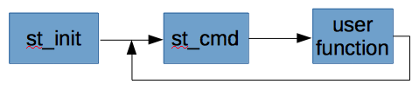

The change of states occurs as commands are received by Pi. Each command should be parsed inside the “st_cmd” state, and call a function that implements the actions required by the command.
For the benefit of productivity, the re-implementation of the full server application is discouraged.

The low-level functions that communicate with MSXPi Interface are implementing using a bit-bang SPI-like protocol, thus it is serial. Due to this, performance is not impressive, but it is an easy implementation using simple and cheap hardware.

The main state of the application is "st_cmd", which validates incoming commands, initializes all attributes necessary to execute each command, and call the specific function for the command.

The code structure that decodes a command and prepares the call to the function is shown below.
} else if((strncmp(msxcommand,"PDIR",4)==0) ||
(strncmp(msxcommand,"pdir",4)==0)) {
printf("PDIR\n");
if (pdir(msxcommand)!=RC_SUCCESS)
printf("!!!!! Error !!!!!\n");
appstate = st_cmd;
break;

For the given example above, the functions is implemented as show next:
int pdir(unsigned char * msxcommand) {
memcpy(msxcommand,"ls ",4);
return runpicmd(msxcommand);
}

MSXPi Server in Python
Soon.

SPI Implementation in the MSXPi Interface

Communication between MSX and Raspberry Pi is facilitated by the MSXPi Interface, which implements a serial protocol using CPLD technology. The protocol uses five GPIO pins and full duplex transfers.
The GPIO pins implements the signals:
- CS (Enable signal from MSX, tells Pi that transfer should start)
- SCLK (Clock signal from Pi, tells MSX when to drive GPIO signals)
- MOSI (Data from MSX to Pi)
- MISO (Data from Pi to MSX)
- SPI_RDY (Ready signal, tells MSX when Pi is read to start a byte transfer)

When Pi is ready to process a transfer, it drive the SPI_RDY signal high.
When MSX wants to start a byte transfer, it checks SPI_RDY. If it is high, MSX drive CS low.
When CS toggle states, Pi jumps to an interrupt function to process the transfer if the signal went low. In this case, it also drive SPI_RDY low to tell MSX that it cannot send another byte.
PI starting generating the clock signal SCLK to synchronize the transfer, and send the 8 bits to MSX. MSX will receive each bit and use bit shift to store in a buffer.
When 8 bits are transferred, PI bring SPI_RDY high again to tell MSX that it can receive more data. The MSXInterface will keep the byte in its buffer. MSX can now send a read command to port 0x5A to get the byte.

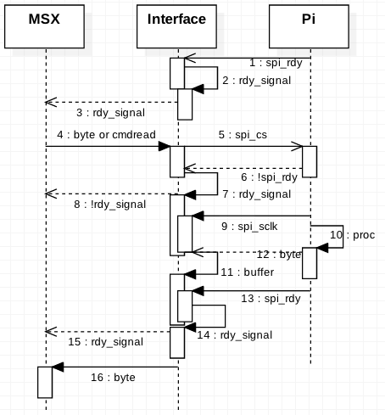

Illustration 2: Diagram Sequence for the Interface

Appendix

Development Tutorial

This appendix will be expanded (hopefully some day) with some useful contents.
As for now, please refer to the Documents/DevTemplate directory in the git repository for a template to use for development.
Also refer to the source codes available, specially under Client directory, for examples of implementation.

Previous Versions
This section contain information about previous versions hardware and commands.
The hardware can be upgraded to use all new funcitons, but the old software will be deprecated and not supported. It is recommended to update the CPLD with the ne logic using the new ports (0x56, 0x57, 0x5a) This will facilitate udpating the software since it won't require a specific build using the old ports (0x5, 0x6, 0x7).

MSXPi Client Commands
Note: This client is deprecated. To use this client, yo must swicth the MSXPi Server form python to the C server. Please use the commands from MSX-DOS or CALL from BASIC.

After starting the client with command “call msxpiload”, the following is displayed in the screen.

Note: List of available commands may vary depending on the version you are using, since MSXPi is under constant development.

MSXPi Hardware Interface v0.7
MSXPi Cloud OS (Client) v0.8.1
TYPE HELP for available commands
CMD:
The available commands can be viewed with the HELP command:
CMD:HELP
BASIC CHKPICONN CLS PDIR HELP PLOADBIN PLOADROM PMORE #(Pi Command) PRESET
CHKPICONN: will verify if Pi is responding. Result will be printed on screen, depending on status.
DIR: will show files in current path. Dir will work for files on the Raspberry Pi filesystem, and also remote
PLOADBIN/PLOADROM: Load a binary program into memory. Currently supported formats are binary files to run from BASIC (PLOADBIN), and .rom (PLOADROM for roms up to 32KB. The loader is very basic and cannot load all rom types.
File is loaded into the address extracted from the header, even for a ROM file. In this case, inter-slot calls are made to write the rom into page 1 (0x4000), which makes the load process slower.
RESET: Sent reset command to both MSXPi interface and MSXPi Server application.
# (PRUN on MSX-DOS): This command passes all commands directly to the Raspberry Pi for execution. The command is executed, and the output printed in the MSX screen. It does not support input to the command, such as prompts. The command must execute and terminate, returning control to the MSXPi.
Examples of usage:
#ls
#pwd
#hostname
#unzip msxgame.zip

For ROM-less MSXPi
MSXPi prototypes that was released without EPROM should be used with the “P” commands from MSX-DOS or loading the MSXPI CALL extensions. All functionalities of new MSXPi intrfaces are avaialble for the ROM-less interfaces, with the exception of the MSXPi-DOS unless you write the MSXPi-DOS.rom to a flashrom cartridge. In such case, it behaves the same as a fully MSXPi interface. For this purpose, the file MSXPi-DOS_16K.ROM can be written to the flashrom cartridge and MSXPi will work as a regular MSXPi with integrated EPROM.
This method can also be used to test new ROM releases before writing it to the final EPROM.

Appendix 2: Pi - GPIO Pin Numbering
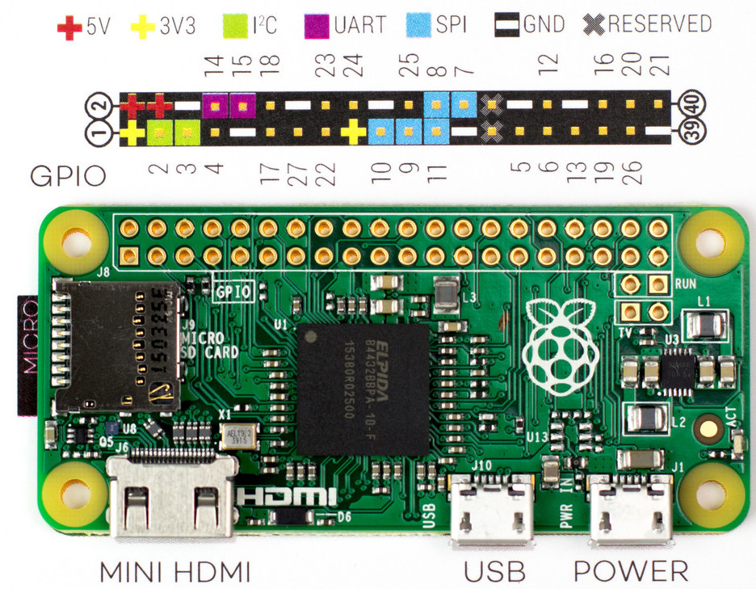

Illustration 4: GPIO models B +, 2, 3 and Zero.

The GPIO numbering of illustration 4 is valid for B +, 2, 3 and Zero models.

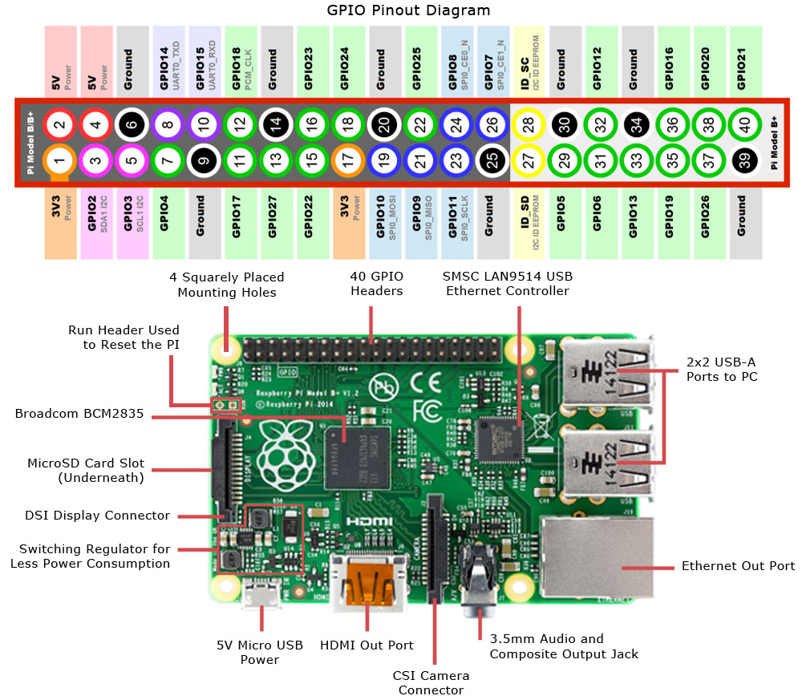

Illustration 5: GPIO models B +, 2, 3 and Zero.

